**Boot process in Linux OS (6&7)**

The boot sequence start when we turn on the computer and it is continues until our computer reach login prompt.

**Below are the booting steps of Linux OS:**

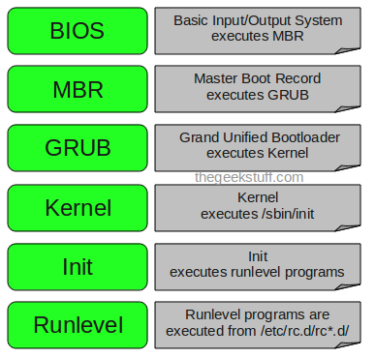

1. When we press the power on button, first of all BIOS (Basic input output system) loaded and it looks the boot loader as sequence ( CD, Floppy or Hard disk ) and proceed with boot loader program in the memory. Then, it loads and execute the MBR.
2. Now, MBR ( Master boot record ) which is located in first sector of your bootable disk and it contains primary boot loader information and partitions table of your bootable disk. After reading the partition table it find the GRUB location and load it in system memory.
3. Now, GRUB ( Grand Unified boot loader ) loads the kernel image and initramfs/initrd image. You can choose any kernel version in grub but by default it load the kernel as mentioned in its configuration file.

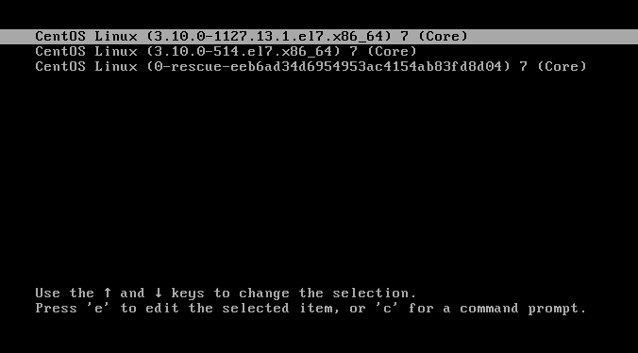

GRUB configuration file in Centos vir7 :

/etc/grub2.cfg is the soft link with -> /boot/grub2/grub.cfg



GRUB configuration file in Centos vir6 :

/etc/grub.conf is soft link with -> /boot/grub/grub.conf



1. **Kernel :** Kernel is the core part of operating system which act like a bridge between applications and hardware of the computer.

Kernel load the initial root file system and necessary driver modules which need to load the real root file system with the help of initrd (initial ram disk)/initramfs(initial ram file system) image. After that it start the init process (in Linux 6) or systemd process (in Linux7).

1. **In Linux 6:**

The init process load the default runlevel as mentioned in the “/etc/inittab” file and and it load the services as per “/etc/rc.d/rc*.d/” file after that we reached into the login prompt.

**In Linux 7:**

The systemd process load the default target (same as runlevel in linux6) as mentioned in file “/etc/systemd/system/default.target”. And after that it load the all services which is mentioned in the file “/etc/systemd/system/multi-user.target.wants/” after that we reached to the login prompt.

For more info follow : <https://www.linuxbuzz.com/step-by-step-linux-rhel-6-7-boot-process-for-beginners/#:~:text=MBR%20looks%20for%20boot-loader,and%20then%20login%20prompts%20comes.>

**Runlevels & Targets :**

Both runlevel and target are same but in Linux7 runlevels are replaced with targets.

Runlevel is the state of machine which defines which services should be run on the system. Runlevel are defined as 0 to 6.

|  |
| --- |
| **Runlevel 0 – For shut down the system** |
| **Runlevel 1 – single mode {(Only one user(root) can login on the system and no network ssh service will run}** |
| **Runlevel 2 – multiuser mode {more than one user can login but without networking(means no SSH only on console)}** |
| **Runlevel 3 – multiuser with network (you can access your machine by SSH and all services will be available)** |
| **Runlevel 4- customized runlevel (not in use)** |
| **Runlevel 5 – graphical mode (Same as runlevel 3 but with GUI mode)** |
| **Runlevel 6 – Reboot the system** |

In Linux6 : you can change your default runlevel by modifying file “/etc/inittab”

In Linux7 : you can change your default target by modifying fiel “/etc/systemd/system/default.target”.

Thanks.! 😊